AWS Database RDS for the database
Full Configuration
Database Engine: MySQL 8.0.40
Free Tier
database name: database01
master user name: admin
self managed
public access: Yes
password: cloudpassword
instance type: standard
Don't connect to EC2 instance
Create new security group
sgdatabase01
password authentication
update the security group sgdatabase01 from EC2 security groups: MySQL/Aurora AnyIP

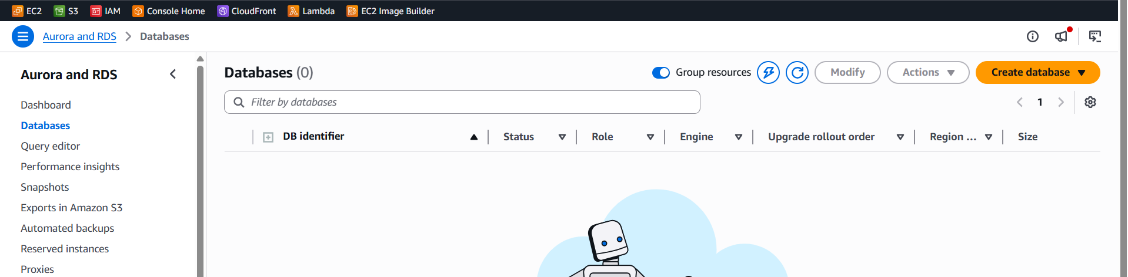
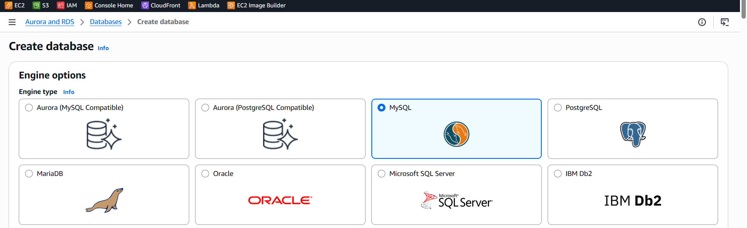
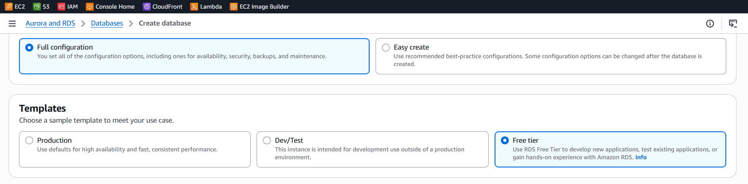
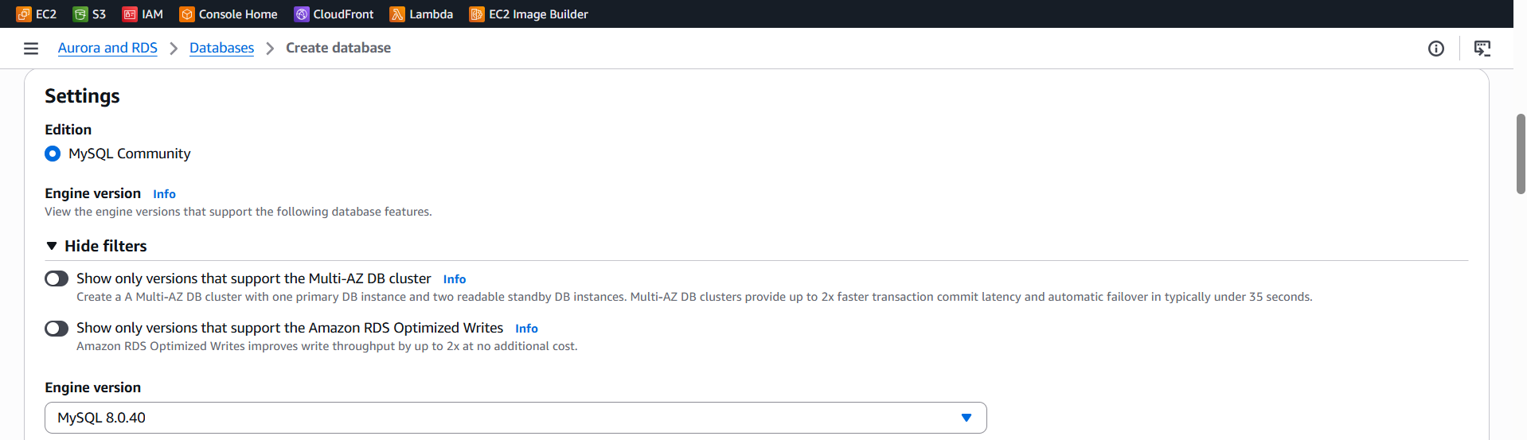
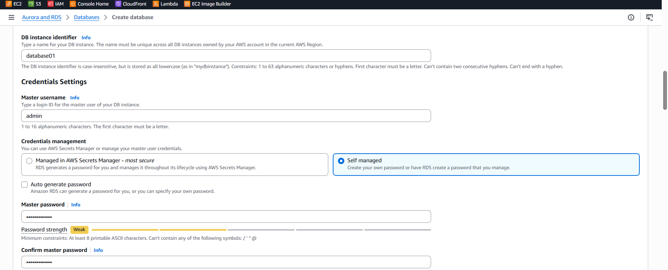
Test connection to the database using the VS code database client extension.
Select: Mysql
Host: the endpoint url of the database
User: admin
Password: cloudpassword
Database: company

AWS EC2 Instance for the Backend

Launch an instance:
Windows 2025 base.
- Create a new keypair and pick aname for it. You will use it to decrypt the password and connect through remote desktop to the server.
- Security: enable all inbound traffic from any IP address. This is not secure but work temporarily for the demo.
- Windows firewall: disable all firewalls on all network for the server. The best option is to pick the ports needed and allow them to deny every other port.
- Using connect -> download remore desktop file. Use getmy password and the keypair file to decrypt the password and use it to connect to the server.
- In the remote desktop use another user:
  - Administrator
  - The password you got from the decryption.
- Install Dotnet 9.0 SDK (v9.0.14) from the installer.
https://dotnet.microsoft.com/en-us/download/dotnet/9.0

- Download the backend code from: https://github.com/abushattal01/labdemo
- Unzip the folder and run the backend server. Test backend app from postman from your local computer using the public IP address of the server. No need for VS code you can run the application from the terminal.

